May 31, 2022 - June 3, 2022
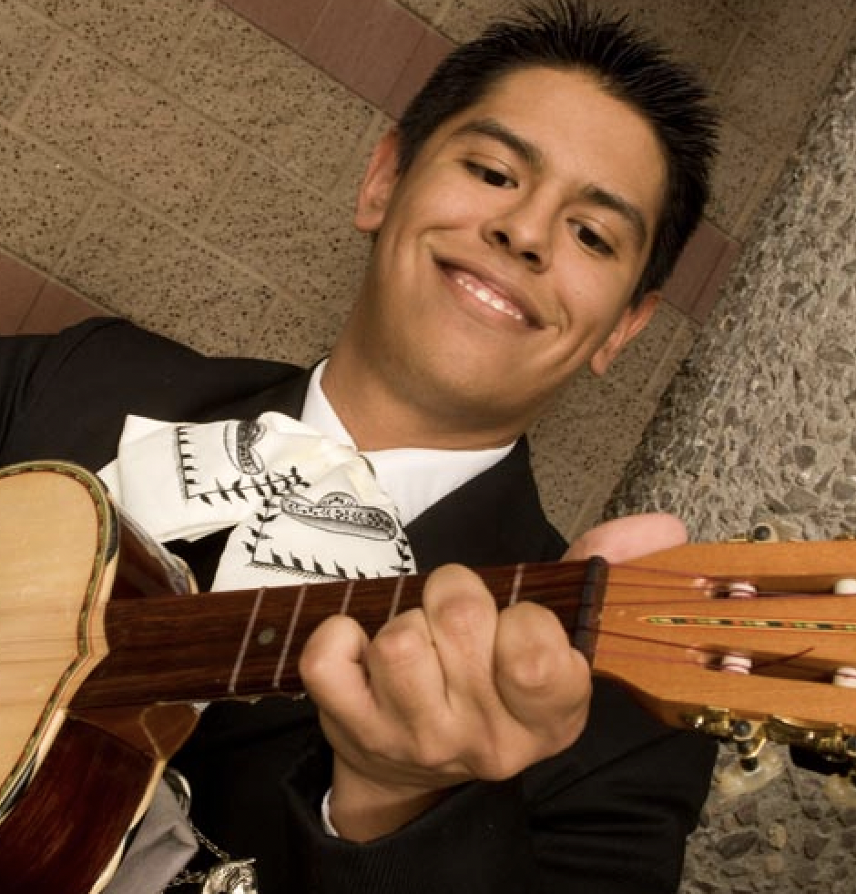
Fernando Aguilar Johnny Gonzalez Robert Lopez
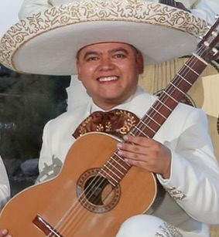
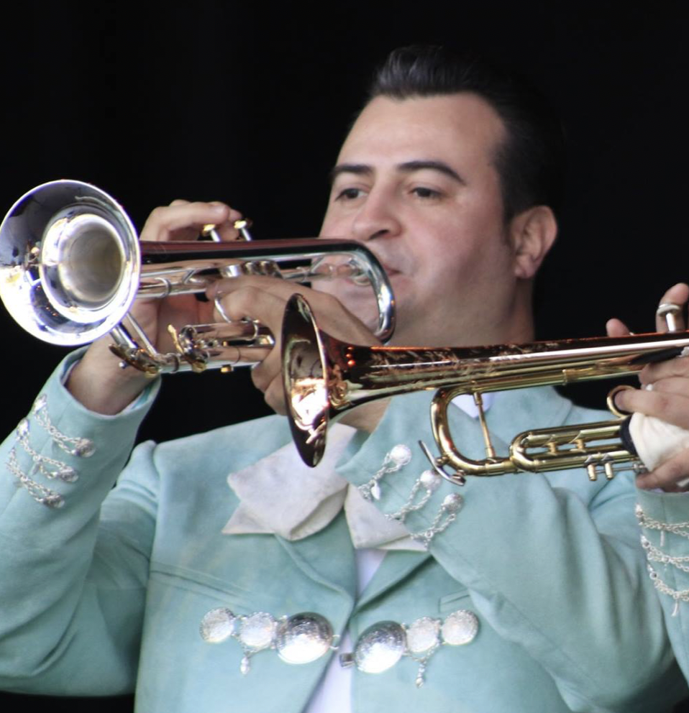
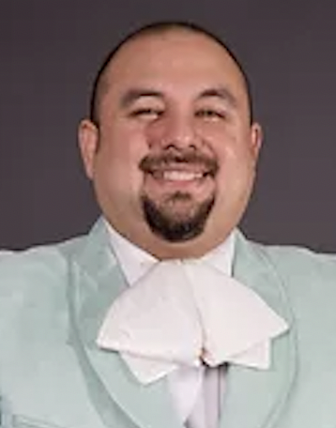



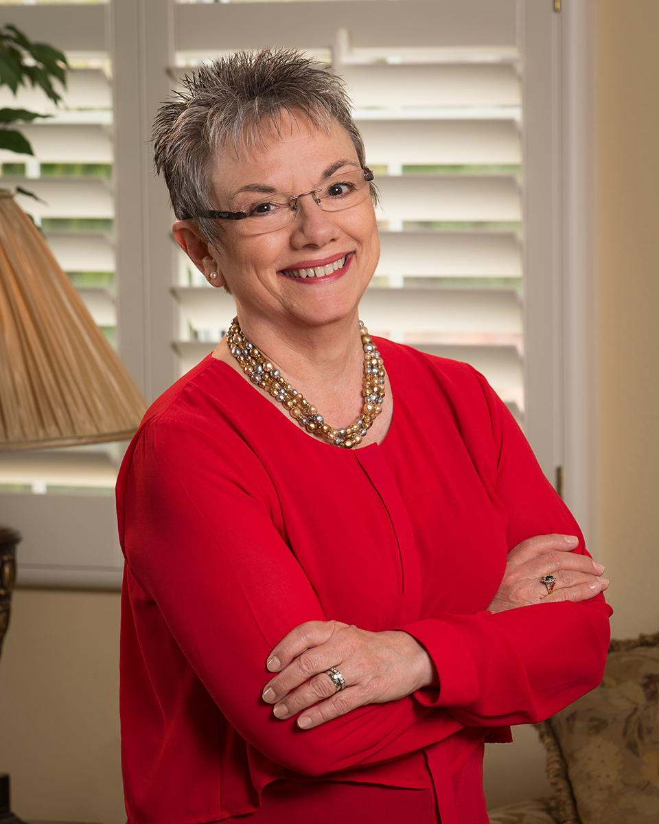
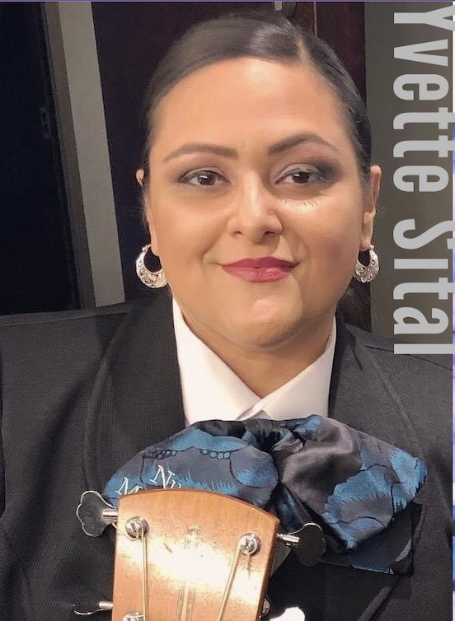
Music Education Consultants, Inc. and
The NAMM Foundation
2022 NATIONAL MARIACHI WORKSHOPS FOR EDUCATORS
Erik Ramirez Yvette Sital Miriam Vazquez
Jose Hernandez Marcia Neel Willie Acuna
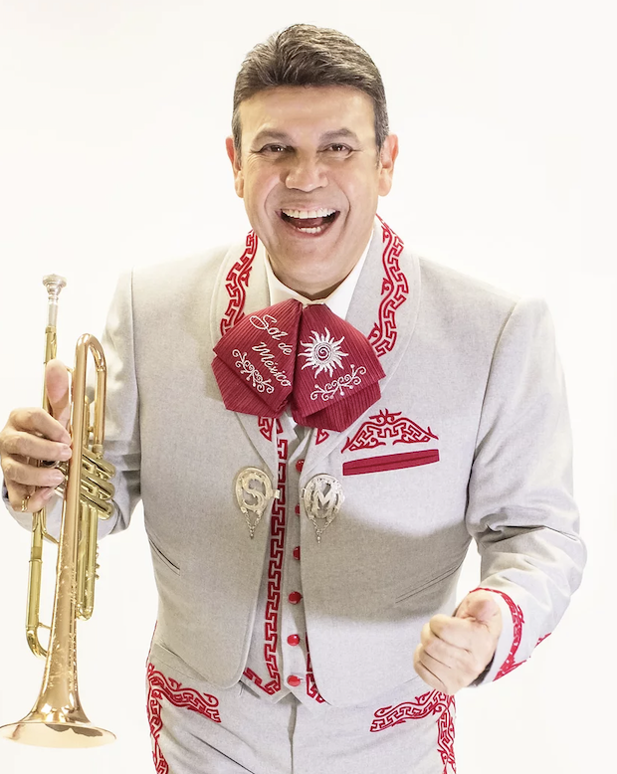
Presented by
BEG
