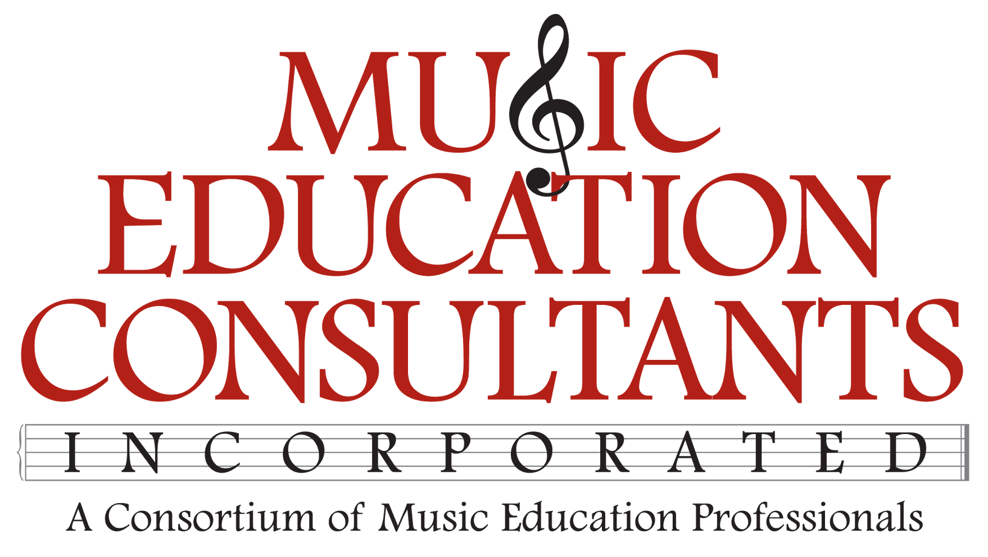

THE CLEVELAND ORCHESTRA ONLINE LESSON LEARNING LIBRARY
MONTHLY PROGRESS REPORT
November 1, 2023

Tasks Completed
- Research to ensure that the broad spectrum of activities included in the lessons are age appropriate for the developmental levels of each grade level’s pre-existing lessons.
- Research to align the edited lessons with Ohio State Learning Standards and the National Music Standards.
- Taught music lessons to 110 children, grades 1-5, for a half day in Austin, TX to confirm that the developmental and cognitive abilities of young children are consistent with the musical and non-musical tasks and skills included in the edited Learning Library lessons.
- Developing a curriculum map to track the quantity and scope of the Ohio State Learning Standards and National Music Standards included in the edited Learning Library lessons.
- Drafts written for second grade lessons:
  - Cultural Connections
  - Lollipop Bop

In Progress
- Draft 2nd grade lesson, Peter and the Wolf

